Note: Include this page only when adding / amending / deleting a document. If using this document as a record, this Revision History page can be omitted.

REVISION HISTORY

Revision no | Date | Description of Changes | Reason for Revision | Revised by | Approved by
1 | 01 June 13 | Add revision history page | - Recommendation from Stage 2 audit | RDPlacido
2 | 8 Apr 16 | Added disclaimer when printing the document | For document control | RCGanal | MVBergantin
TM-BR-MG- 11 Rev00, 05302012

I. Objective
To ensure that an employee who leaves the organization is cleared from any labor and legal accountability and to identify company practices that need to maintain and improve in order to minimize attrition.
II. Scope
This procedure defines the action and responsibilities of the HR Head in the exit management. This covers activities from the receipt of the intention to separate to updating of records.
III. Definition of Terms
Voluntary Resignation | Is a voluntary act of an employee who finds himself in a situation where he believes he has to disassociate himself from his employment because of his/her personal reasons.
Termination | Is the act of the employer to end the services rendered by the employee on the grounds allowed by law.
Exit Interview Form | Is a questionnaire filled-out by resigning employees.
Exit Interview | - Is an interview conducted by the HR Head to verify the answers written in the exit interview form.  - Face-to-face interview is voluntary and is conducted only to regular employees.
Clearance Form | Is a record proving that the employee has no longer accountability from the company
Request Form | Is a form filled out by the resigning employee only if he is requesting records from the company. This is not compulsory on the date of resignation.
Clearance Summary Report | Is a summary report listing all resigned employees, their last day of employment, reason for leaving and the status of their clearance.

IV. Procedure Details
Responsible | Activity | Interface
HR Head | 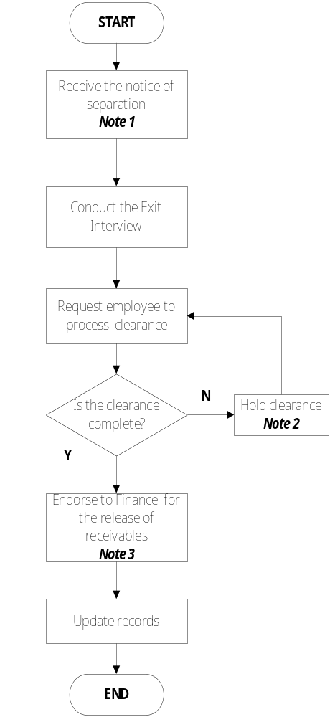 | Employee Unit Head Resignation Letter Termination Letter Guidelines in Resignation Guidelines in Termination  Exit Interview Form  Last Approved Timesheet Signed Clearance Form Company ID and HMO card Clearance Form Accomplished Exit Interview Form  Release and Quitclaim Deed Certificates AP Accountant  EMS 201 File Clearance Summary Report
Notes:
- Notice of Separation could be in two folds: it could be voluntary resignation or termination.
- Advise employee to complete necessary requirements as his/her receivables will not be released if his/her clearance is on hold.
- Only employees, who voluntarily resigned and are cleared, will have his/her receivables (e.g. last pay, 13th month pay, cash conversion of benefits, training certificates, certificate of employment). In accordance to the Philippine Labor law, terminated employee shall receive whatever rights, benefits and privileges he/she may have under the voluntary employer policy or practice, provided he/she is cleared.

V. References
- Clearance Form
- Exit Interview Form
- Release and Quitclaim Deed
- Request Form
- Guidelines for Employee Resignation
- Guidelines for Employee Termination
- Guidelines for Preparation of Attrition Report

VI. Quality Records
- Resignation Letter
- Accomplished Clearance Form
- Filled-Out Exit Interview Form
- Filled-Out Request Form
- Signed Release and Quit Claim Deed
- Clearance Summary Report
- Attrition Report

